Game Design Document

Fill up the following document

1. Write the title of your project.

Rise of the UNDEAD.

1. What is the goal of the game?

The goal is to kill 100 zombies.

1. Write a brief story of your game.

All of the greatest scientist of the world decided to work on a project that will make human life last longer that usual. But the project goes wrong which results in the Zombie virus. The person who was choosen to test the project on became a zombie and started bitting all of the other scientist. As a result all the scientist became zombies and started infecting more and more people. The speciality of this virus was that it could also infect animals. So it was spreading faster than any other virus. Now to prevent the virus from spreading, the Hunter has to kill all the zombies.

1. Which are the playing characters of this game?

* Playing characters are the ones who respond to the user based on the input from the user.
* Cars, monkeys, dinos, wizards, etc., are the playing characters in the game.

|  |  |  |
| --- | --- | --- |
| Number | Character Name | What can this character do? |
| 1 | Hunter | He can shoot bullets and walk around. |
| 2 |  |  |
| 3 |  |  |
| 4 |  |  |
| 5 |  |  |
| 6 |  |  |
| 7 |  |  |
| 8 |  |  |

1. Which are the Non-Playing Characters of this game?

* Non-Playing characters are the ones that don't have an action or behavior when the user interacts with the game.
* Hurdles, stones, bananas, coins, etc., are non-playing characters in the game.

|  |  |  |
| --- | --- | --- |
| Number | Character Name | What can this character do? |
| 1 | Zombies | They can take away one the lives of the hunter |
| 2 | Zombiefied Birds | They can also take away one of the lives of hunter but they are a bit faster and they can also fly |
| 3 | Zombie giant | They can take away more than one life of the Hunter but they are slower |
| 4 | Speedster zombie | They are fast but also easy to kill |
| 5 |  |  |
| 6 |  |  |
| 7 |  |  |
| 8 |  |  |

Draw your imagination of this game. What does this game look like?

* Draw the game either on your computer or on paper.
* Add images of the game scenes to show each of the playing and non-playing characters at least once.

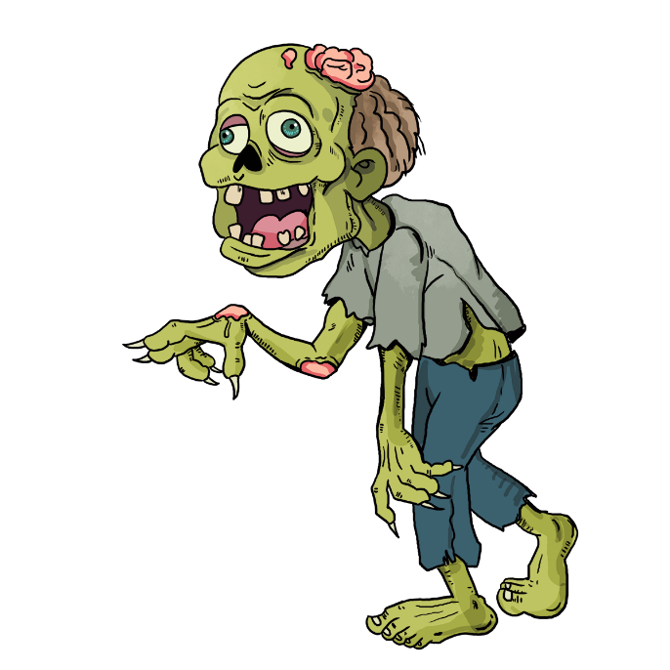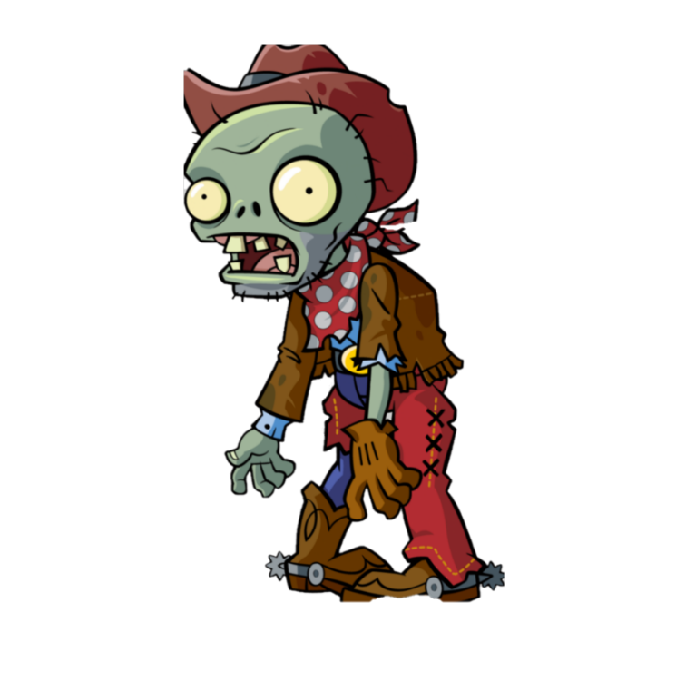

How do you plan to make your game engaging?

The addition of different zombies and birds which have different abilites, strength, speed,etc. Giving the player different types of weapons on a certain point.